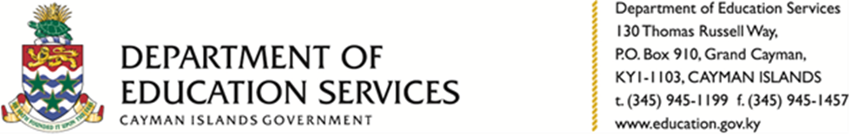

**PRESS RELEASE**

**DES Hosts NCFA Workshops**

**Grand Cayman, Cayman Islands, 15 December 2020.** The Department of Education Services (DES) last Monday (7 December) held workshops on Traditional Dance, Speech and Drama for teachers as part of its Professional Day activities and in preparation for the 2020/2021 staging of the National Children’s Festival of the Arts (NCFA).

“At the close of the 2019/2020 staging of the NCFA, traditional dance, speech and drama were identified as areas for development,” explained DES Acting Customer Service Manager Gloria Bell. “Professional Development Day offered the opportunity for us to host the workshops and provide our teachers with a chance to learn and in turn, share our culture with our students,” Mrs. Bell continued.

A total of 28 teachers from government-operated and private schools across Cayman attended the workshops which were held at Prospect Primary School.

Mrs. Norma Ferryman of the Special Support Services Unit and Mr. Brian Watler of the Cayman Islands National Museum led the dance sessions where attendees were taught techniques relating to traditional Caymanian dances such as Quadrille and May Pole.

The poetry workshop was led by Mrs. Leslie-Ann Bernard, head of drama at JGHS who taught attendees how to interpret poetry for performance and direct a poetry performance.

East End Primary School educator Mr. Troy Rodgers described the workshops as informative.

“I was excited to have been exposed to that style of Quadrille and to have experienced that aspect of the Caymanian culture. It was great to have gotten the 'Judges' perspective along with the practical elements of directing a poetry performance. I look forward to the next season of the NCFA” he stated.

The 2020/2021 season of the NCFA commences on Friday, 29 January per the below schedule:

**CALENDAR OF EVENTS**

|  |  |  |
| --- | --- | --- |
| **AREA** |  | **DATE** |
| **Registration – All categories** | **Submission of NCFA Entries** | **29th January, 2021** |
|  |  |  |
|  |  |  |
| **Cayman Brac & Little Cayman** | **Music** | **25th Feb. 2021** |
| **Performing Arts** | **Speech, Drama & Dance** | **26th Feb. 2021** |
|  |  |  |
| **Grand Cayman Performing Arts** | **Vocal – Solos & Choirs** | **1st -2nd March 2021** |
| **Solo Competition – KS1, KS2 & KS3** | **Instrumental** | **2nd March 2021** |
|  | **Speech: Solos & Speech Choirs** | **3rd March 2021** |
| **Sponsored by CICSA Co-op Credit Union** | **Instrumental Ensembles & Bands – all students** | **4th. March 2021** |
|  | **Drama** | **5th March 2021** |
|  | **Dance** | **5th March 2021** |
| **Sponsored by Bank of Butterfield** | **2020 Young Musician of the Year** | **17th April, 2021** |
| **Amin Mohammed Memorial**  **Steel Band Competition** | **Sponsored by Cayman National Bank** | **24th April 2021** |
|  |  |  |
|  |  |  |
|  |  |  |
| **Final Concerts** | **Cayman Brac & Little Cayman**  **Grand Cayman** | **6th March 2021**  **29th April- 1st May, 2021** |
|  |  |  |

The NCFA was established in 1982 and is aimed at showcasing the skills and talents of students in the performing arts.

For more NCFA news and updates, contact DES Senior Customer Service Officer Nicki Samuels by telephone at 945-1199 or by email at [Nicki.Samuels@gov.ky](mailto:Nicki.Samuels@gov.ky) or Mrs. Gloria Bell by telephone at 926-9727, or 945-1199 or by email at gloria.bell@gov.ky.

-ENDS-

Media Contact

Stacey-Ann Anderson

Communications Officer

Ministry of Education, Youth, Sports, Agriculture and Lands

[StaceyAnn.Anderson@gov.ky](mailto:Patrice.beersingh@gov.ky)

**Photo Captions**

**Photo A**: Leslie-Ann Bernard (standing) teaches workshop participants about speech and drama techniques

**Photo B:** Workshop participants demonstrate the May Pole dance

**Photo C:** A group of workshop participants demonstrate the Quadrille dance