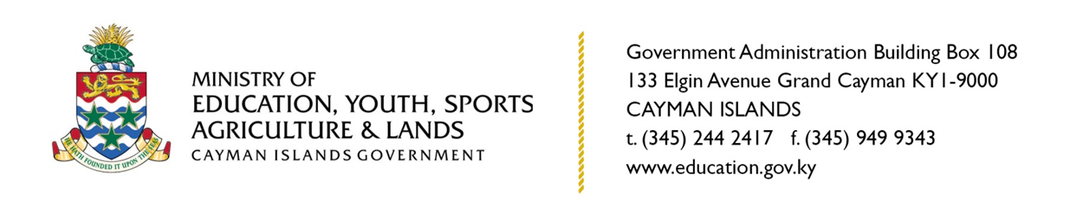

**PRESS RELEASE**

**MEYSAL Adjusts Start Date of Term Two of the 2020-2021 Academic Year**

**Grand Cayman, Cayman Islands, December 4 2020.**The Minister of Education Youth, Sports, Agriculture and Lands (EYSAL) Hon. Juliana O’Connor-Connolly has announced an adjustment to the previously published Term Two start date of Monday, 4 January 2021 to Monday, 18 January 2021 for Government Schools. The announcement was made during the Grand Cayman Teachers’ Appreciation event at The Kimpton Seafire Resort last Saturday (28 November).

Hon. Minister O’Connor-Connolly stated, “Having realised the impact of the COVID-19 pandemic on the physical, mental and emotional wellness of our educators, many of whom have not been able to reconnect with their families since the onset of the COVID 19 pandemic, as well as the impact of the requirement to isolate for two weeks upon their return to the Cayman Islands on their ability to travel, the Ministry has extended the Christmas holiday period by two weeks to allow staff from government schools to spend some well-needed time with their families locally and overseas.”

Clifton Hunter High School Principal, Dr. Richard Wildman agreed that this extended break would be beneficial to his staff. “The extended Christmas break will have a positive impact on the staff at Clifton Hunter High School. It creates an opportunity for the staff to fully recharge and prepare for the remainder of this academic year."

Approximately 180 teachers or 22 percent of the staff cohort in government schools initially indicated their desire to travel during the Christmas break.

“The Ministry of EYSAL has had consultation with the Department of Sports, the Youth Services Unit (YSU) and the Young Men’s Christian Association (YMCA) through the Extended After-school Programme, to ensure that activities are put in place to engage our children and young people during the extended break,” Minister O’Connor-Connolly continued.

Deputy Governor and Head of the Civil Service Hon. Franz Manderson says the civil service will support employees who may need to make alternate child care arrangements. “The civil service will institute flexible working arrangements for civil servants whose children attend public schools,” Mr. Manderson stated. “Civil servants who are affected by school closures are requested to refer to CIG’s existing policies on Remote Working and Flexible Work Hours when requesting consideration by their managers,” he added.

The Ministry and the Department of Education Services (DES) have further announced that they are working closely with the airlines and the Health Services Authority (HSA) to facilitate travel and to ensure that proper public health protocols are observed.

“The Department of Education Services has also recognised the implications that this adjustment may have on the instructional time and has implemented appropriate measures to ensure that our students will receive 185 teaching days as outlined in the Education Law 2016,” Senior School Improvement Officer (SSIO) Ian O’Connor added earlier this week while deputizing for the DES Director.

In adhering to the legal requirement of 185 instructional days in an academic year, DES and MEYSAL noted that 3 storm days also needed to be recouped during the 2020-2021 academic year due to the passing of Hurricanes Delta and Eta. The following additional changes to the school calendar have therefore also been approved to ensure compliance with the Education Law:

**Adjustments to dates during the 2020-2021 academic year**

|  |  |
| --- | --- |
| Original Dates | Revised Dates |
| Start of Term 2 on January 4th 2021. | **Start of Term 2 on January 18th 2021.** |
| Half-term holiday from February 15th – 19th 2021, with Ash Wednesday (February 17th 2021) as a Public Holiday. | **February 15th, 16th, 18th and 19th 2021 set as school days, with Ash Wednesday (February 17th 2021) as a Public Holiday.** |
| Professional Development Day on March 26th 2021. | **March 26th 2021 set as a school day.** |
| Easter Break from April 2nd – 9th 2021, with Good Friday (April 2nd 2021) and Easter Monday (April 5th 2021) as Public Holidays. | **April 8th and 9th 2021 set as school days, with Good Friday (April 2nd 2021) and Easter Monday (April 5th 2021) as Public Holidays, and April 6th and 7th 2021 remaining as part of the Easter Break.** |
| School year ends June 30th 2021. | **School year ends July 9th 2021; July 5th 2021 is a Public Holiday.** |
| Important Notes for the 2021-2022 School Calendar | |
| * New staff, Principals and Deputy Principals return to work the week of August 16th 2021. * All other staff return to work the week of August 23rd 2021. * Students return to school the week of August 30th 2021.   Exact dates will be provided with the release of the 2021-2022 School Calendar. | |

Private schools may make arrangements as they see fit, also being mindful of the legal requirement of 185 instructional days during the year.

MEYSAL will continue to provide any additional updates through the official channels for the latest government news and updates.

For the latest government news and updates, visit [www.gov.ky/all-news](http://www.gov.ky/all-news).

MEDIA CONTACT:

STACEY-ANN ANDERSON

COMMUNICATIONS OFFICER

MINISTRY OF EDUCATION, YOUTH, SPORTS, AGRICULTURE AND LANDS

E: staceyann.anderson@gov.ky